**How To Make a Simple 3D Game in Unity**

**(As demonstrated by your favorite TL2’s)**

Step 1:Create a new project.

* Open Unity.
* Click File -> New Project
* Select the location for your project.
* Name your project.
* Click Create.

Step 2: Customize the layout.

* Manipulate the 5 main windows (Scene, Game, Hierarchy, Project, and Inspector) as you would like.

Step 3: Save the scene & set up the build.

* Click File -> Save Scene. Save the scene under the folder [Project Name] - Assets.
* Save the scene as Scene or Main.
* Click File -> Build Settings.
* Add the current scene to build.
* Select desired platform.
* Click Player Settings at the bottom of the Build Settings window.
* Close out of the Build Settings window.

Step 4: Create the stage.

* To add cubes, go to Game Object -> 3D Object -> Cube, or use the Create menu in the hierarchy window.
* Add a cube.
* Reset the cube’s transform by right-clicking “Transform” in the Inspector panel.
* Select the cube in the Hierarchy. Rename it “Wall” by double-clicking its name in Hierarchy or using the Inspector panel.
* Scale the cube in the X direction to make it long and wall-like.
* Right-click “Wall” in the Hierarchy panel, and duplicate it three times so you have four walls.
* Create an empty GameObject, using the GameObject dropdown. (Create Empty) at the top of the screen.
* Call it “Stage”.
* Reset its transform.
* Select all four “Walls” and drag them under the “Stage” GameObject.
* Add a plane GameObject by selecting Create in the Hierarchy panel and use it for the floor. Rename it “Floor”, and drag it under Stage in the Hierarchy.
* Give the floor a -.5 transform in the Y-direction to ensure it lines up neatly with the four walls.
* Make the floor’s scale in the X, Y, and Z directions 1/10 of the scale you used to size the walls.

Step 5: Create the player.

* Go to GameObjects -> 3D Object -> Sphere
* Select the sphere in the Hierarchy, and rename it “Player”. Reset its transform.
* Make the player subject to the laws of physics by clicking Add Component at the bottom of the Inspector panel with the player selected.
* Add Physics-> Rigidbody. Leave all the default settings.
* In the Projects panel, right-click and go to Create-> Material and name this new material PlayerMaterial.
* Drag PlayerMaterial onto Player in the Hierarchy.
* Make a new folder “Materials” in Project Panel and move the material into it.

Step 6: Making the player move around.

* Select the player in the Hierarchy.
* Minimize the components that you don’t want to see open in the Inspector by clicking the down arrows to the left of the name of each component.
* Click Add Component at the bottom of the Inspector window. Select New Script, name the script something like “PlayerController”.
* Click Create and Add.
* To keep organized, open the Assets folder in the Project window and create a folder called Scripts.
* Put your new script in this folder.
* Double click the script’s name in the Inspector, or open it from the Project window. This will open the script in an editor, generally Visual Studios if you have that installed.
* Add a function “void FixedUpdate()” in order to handle physics-related protocols.
* Declare a “public float speed;” before start() that we can adjusts to determine the speed at which our character moves around the arena.
* Under FixedUpdate, declare two more floats: moveHorizontal and moveVertical.
* Add: float moveHorizontal = Input.GetAxis(“Horizontal”);
* Add: float moveVertical = Input.GetAxis(“Vertical”);
* Create a new Vector3: Vector3 movement = new Vector3(moveHorizontal, 0.0f, moveVertical);
* Input a force on the player to move it around, using rigidbody: GetComponent<Rigidbody>().AddForce(movement*speed*Time.deltaTime);
* Save the C# file and go back to Unity.
* Go to the Inspector panel for the player, and look at the movement script you just created. There will be a box for your public variable, speed. You can change the value of the public variables using the Inspector.
* Make speed equal a number between 100-1000.
* Click the play button at the top of the screen.
* Test out moving the ball using Unity’s default movement keys: either ASWD or the arrow keys.
* Click the play button again to exit out of testing mode.

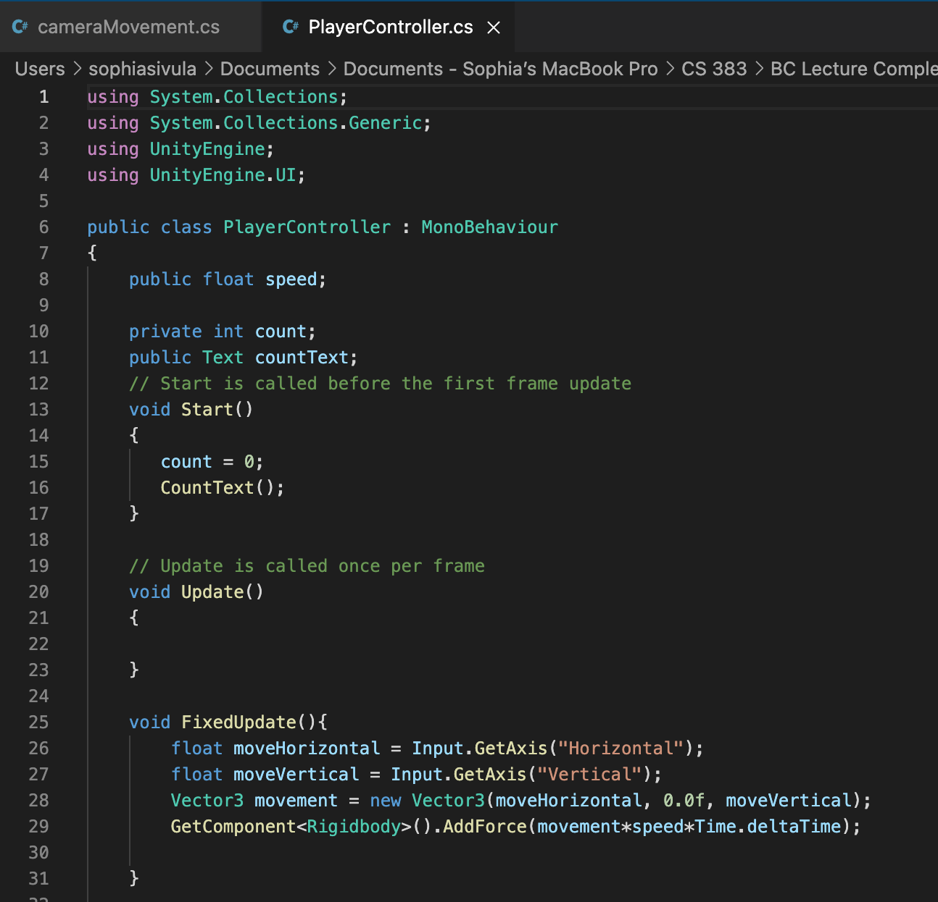

Step 7: Add lighting.

* Create an empty GameObject and call it “Lights”.
* Create a directional light by selecting the option from “create” toolbar in the Hierarchy panel.
* Name it “Main Light”.
* Make it a child object of Lights by dragging it in the Hierarchy onto the Lights game object.
* With Main Light Selected, change the light settings in the Inspector panel by changing Shadow Type to “Soft Shadows” and Resolution to “Very High Resolution”.
* In the Inspector panel, change the main light’s rotation to angle it down over the arena. We used 30X, 60Y, 0Z.
* Right-click the Main Light in the Hierarchy panel to duplicate it.
* Name the duplicate “Fill Light” and child it under Lights.
* Dampen the intensity of the Fill Light by changing the color to a light blue tint and reducing the Intensity field to 0.1 in the Inspector.
* Change Shadows to “No Shadows”.
* Angle the Fill Light the opposite direction of the main light. For us, this was (330, 300, 0).

Step 8: Fine-tune the camera angle.

* Select the Main Camera in the Hierarchy.
* Adjust its transform until the image in camera preview looks good.

Step 9: Make the camera follow the player.

* Create a script called “cameraMovement” by adding a new script component to the Main Camera in the Inspector panel.
* Double click the script to open it in MonoDevelop.
* Declare GameObject player before the script’s Start() function by writing: public GameObject player;
* Create a Vector3 called “offset” by writing: private Vector3 offset;
* Under the Start() function, assign the value of offset to be: offset = transform.position;
* Under a function called LateUpdate(), define the camera’s position as the player’s position plus some offset: void LateUpdate(){ transform.position = player.transform.position+offset;}
* Save the script and go back to Unity.
* Select the Main Camera and look at the Inspector panel.
* Under the cameraMovement script, there should be a box called “Player”. It is currently assigned to None (GameObject).
* Drag the Player from the Hierarchy into this box to assign the player game object to the cameraMovement script.
* Be sure to drag the new script into the scripts folder (in the Project panel).
* Try out the game by clicking the play button at the top of the screen. You should be able to move the player around with WASD or the arrow keys and the camera will follow your movement.
* Save the scene and save the project.

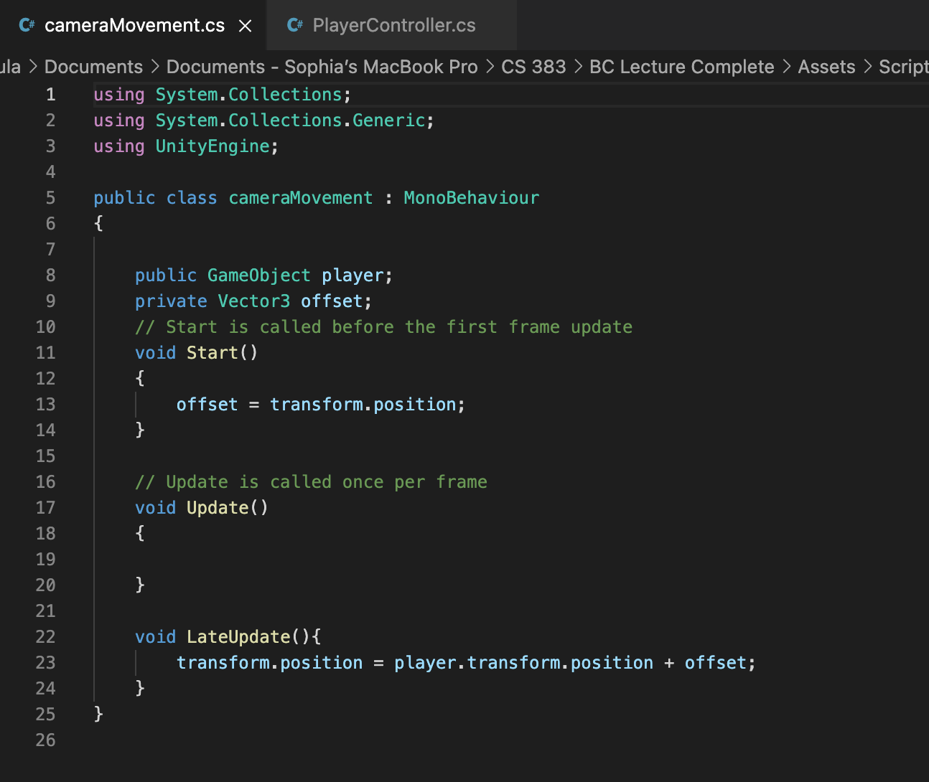

Step 10: Make items.

* Create a new GameObject. It can be a sphere, cube, capsule, or a cylinder. We used a cube.
* Call it “Item”.
* Tag the Item as “item” by selecting Tags, and creating a new tag called “item”, them going back to Tags for that game object and selecting the new “item” tag that you created.
* Tag all your items as items.
* Place the Item into an empty GameObject called “Items”.
* Reset their transforms.
* Add a rigidbody to the Item.
* Create an ItemMaterial in the Project panel. Choose a color, and drag this onto Item in the Hierarchy.
* Move ItemMaterial into the Materials folder.
* Create a ‘Prefabs’ folder in the ‘Project’ tab.
* Drag and drop the cube into it.
* This makes it so that if we change the prefab, Unity will automatically apply those changes to all instances of it in our scene.
* Duplicate the Item a bunch of times and place the copies around the arena.

Step 11: Make the player collect the items & display the score.

* Open the player movement script from the Inspector panel with the Player gameObject selected, and modify the script to allow the player to collect, and keep track of items it has collected.
* Add “using TMPro;” to the top of the script.
  + TMPro stands for “Text Mesh Pro”
  + Useful for clean-cut UI
* When prompted, choose to install the essentials from TMPro
* Make two declarations: one is a variable that keeps track of your score, and other is a GUI text that will display your score on the scene view:

private int count;

Public TMP_text countText;

* Under the function void Start(), initialize count and CountText ( a function we will write later):

count = 0;

CountText();

* Write a new function for what happens when the Player collides with the Items. This should be its own function:

void OnTriggerEnter(Collider other){

if(other.gameObject.tag == “item”){

other.gameObject.SetActive(false);

count = count + 1;

CountText();

}

}

* Write the CountText function, which will update the score on the GUI display:

void CountText(){

countText.text=”Count: “ + count.ToString();

}

* Save the code and switch back to Unity.
* Select all your items, make sure they’re all tagged as items, and check the button “Is Trigger” in the Box Collider component of the Inspector.
* Check the “Is Kinematic” button under rigidbody.
* For the countText, create a new GUI (graphic user interface) Text using the Create option under Hierarchy.
* Create a UI-> Text - TextMeshPro in the Hierarchy.
  + It should create Canvas and EventSystem gameObjects as well
  + DO NOT get rid of either
* Adjust so it’s visible within the camera by:
  + Going to the Canvas gameObject, then the Canvas component, and finally under Render Mode and changing it to ‘Screen Space - Camera’
  + Drag and drop our camera Gameobject into the camera field
  + Decrease the ‘Plane Distance’ until the text is visible in the Game view, I chose 5
  + Select the ‘Text’ element in the hierarchy and click on the square
  + Hold ‘alt’ and select the top left corner to lock our text element there
  + Adjust font size as desired, I chose 100
  + Adjust the rectangle for the text in the scene view as desired
* With the player selected, drag the UI Text into the Count Text box on the Inspector.

Step 12: Make hazards.

* Create a new empty gameObject called “Hazards”.
* Create a new Quad and call it “Hazard”.
* Tag it as “hazard”, and check “Is Trigger”.
* In the Project panel, create a new material and name it HazardsMaterial. Drag this onto Hazards in the Hierarchy, and move the new material into the Materials folder.
* Change the hazard’s rotation to 90 about the X-axis and lower its Y height so it is a small square lying just over the floor of the arena.
* Edit the Player script, under the OnTriggerEnter() function, so that it accounts for the possibility that the object the player runs into is a hazard and not an item. Tell the player to jump if it hits the hazard:

void OnTriggerEnter(Collider other){

if(other.gameObject.tag == “item”){

other.gameObject.SetActive(false);

count = count + 1;

CountText();

}

//tells player to jump if they hit a hazard

if(other.gameObject.tag == “hazard”){

other.gameObject.SetActive(false);

Vector3 jump = new Vector3(0.0f, 30 , 0.0f);

rigidbody.AddForce(jump*speed*Time.deltaTime);

}

}

* Save the code, go back to Unity, and duplicate the hazard a few times.
* Position the hazards around the arena.
* Try out the game by going to Build & Run, save the game, and run it.
* You’ve successfully created a simple 3D game in Unity with C#!

Link to this tutorial: <https://www.instructables.com/How-to-make-a-simple-game-in-Unity-3D/>

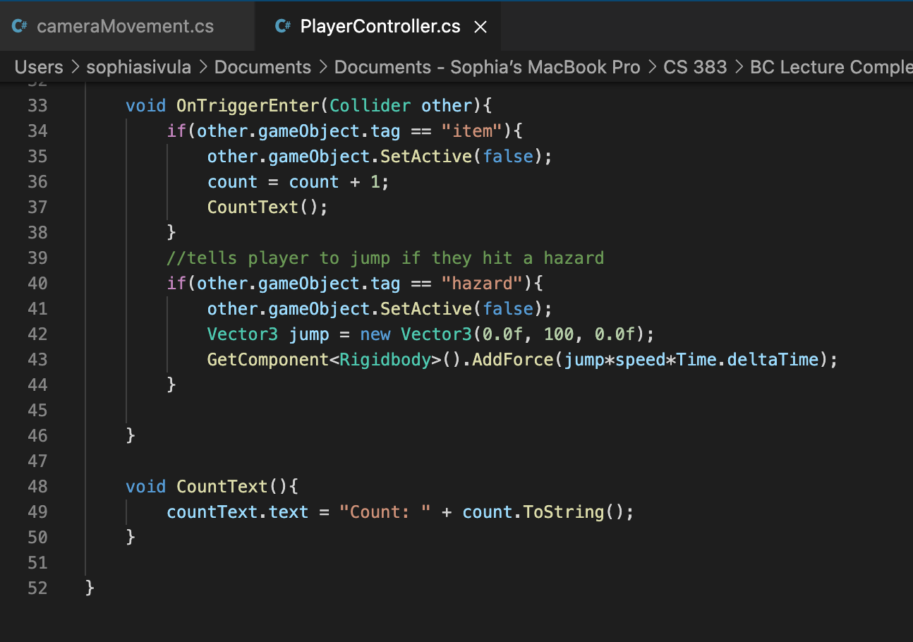

**How to Add Sound Effects:**

Step 1: Add Sound Effects

* Create a new gameObject under ‘Audio’ called an ‘AudioSource’
* Now, make a new ‘Sounds’ folder under ‘Assets’
* Navigate into that sounds folder
* Now follow this link: <https://online-voice-recorder.com/>
* Make and trim down your very own “BOING” sound effect
* Open this up then drag and drop it into our Unity Sounds folder
* Now, go into our Player Controller script
* Add the following code at the top:

public AudioSource boingClip;

* And within the ‘OnTriggerEnter()’ method under the ‘hazard’ if statement, add:

boingClip.Play();

* This should play the audio source’s audio clip every time a hazard is stepped on
* Go back to Unity and drop our audio clip onto the audio source
* Go into the audio source and disable ‘Play on Awake’
* Go to our player and drop the audio source into its field
* Test it out!
* Repeat the process for a cube disappearing sound effect, but make a “BLIP” noise for this one
* Create a ‘Sound Effects’ empty gameObject in unity and put your audio sources underneath there

**How to Create a Superclass and Subclasses:**

Step 1: Superclass and Subclasses

* We’re going to make different kinds of hazards
* We’ll have to alter the player movement script and create some new scripts to go on the hazards
* Call one of the new hazard scripts “HazardAct” and attach it to the hazard gameObjects
* Create a public void method in this script called “DoSomething()”
  + Make sure to specify it as virtual so we can override it later

virtual public void DoSomething()

* Make it print out “Hazard tripped” for now
* Now, open up the player controller script, and down in the OnTriggerEnter() method, add this within the hazard if statement:

other.gameObject.GetComponent<HazardAct>().DoSomething();

* Let’s walk through this slowly.
* So, we access the game object that has a trigger with the tag “hazard”
  + On that gameObject, we assume it had a component called “HazardAct”, which it should because we attached this script to all our hazards
  + Within that “HazardAct” script, we call the DoSomething() method
* Let’s test it out!
  + Make sure to look at the ‘console’ window to see the output
* Now that we’ve verified it works, let’s make something happen
* Create two new scripts: “HazardGameover” and “HazardSpawn”
  + Open both of them up
  + Change inheritance from ‘Monobehaviour’ to ‘HazardAct’
  + Now they’re child classes of our Hazard Act script
  + In both of them, override the original ‘DoSomething()’ method:

override public void DoSomething()

* Within both overridden methods, call the ‘base’ method
* This allows us to access the original method even though we overrode it
* In the ‘HazardGameOver’ overridden method, add this code to make the editor and the actual game quit:

Application.Quit();

EditorApplication.isPlaying = false; //for editor only

* In ‘HazardSpawn’, add this code to have the tripped hazard spawn a duplicate of itself:

Vector3 spawn;

GameObject spawnedPlat;

spawn = transform.position - Vector3.forward;

spawnedPlat = Instantiate(gameObject, spawn, Quaternion.identity);

spawnedPlat.transform.rotation = gameObject.transform.rotation;

spawnedPlat.SetActive(true);

* We instantiate the gameobject this script is attached to, at its current location offset by 1 unit, then set the spawned gameobjects rotation back to the original’s and set it active
* To spawn more, just copy and paste the second section of the code and change ‘forward’ to ‘right’ and ‘left’ and add forward for all four directions
* Finally, go back to Unity and remove ‘HazardAct’ from our hazard prefab, and replace it with our new script
* Test it out!
* When satisfied:
  + duplicate our hazard prefab
  + rename it to ‘logoutHazard’
  + change its material
  + make sure the only script attached is ‘HazardGameOver’
  + Then place it into the scene
* Test it ouuuut
* Note: remove ‘EditorApplication.isPlaying = false;’ before building the unity project.

**How to Create a Start Screen:**

Step 1: Create the Start Screen.

* Create a new scene “Menu” in the Project panel.
* In the Hierarchy, create a UI->Panel.
* Change the Scene to 2D mode, and press F to focus on the canvas.
* Choose a color in the Inspector for your background.
* Click on Panel, and under Color drag the alpha channel to 255. (Alpha channel is the A)
* Rename Panel to “Background”.
* Right-click on Canvas, click UI->Text Mesh Pro - Text.
* Change text to “PLAY”
* Change font size to 84 in Inspector.
* Align text to center, vertically and horizontally.
* Make the text bold.
* Enable Underlay in order to create a shadow. Offset X by 1, Y by -1. Increase softness to .6.
* Under Font Settings, enable a color gradient.
* Create a TextMeshPro-> Color Gradient Asset named Gold in the Project panel.
* Set top left and right to FFC757.
* Set bottom left and right to FF9C31.
* Select Text object, and drag the Gold gradient into the Gradient (Preset) under font settings in the Inspector.
* Change “Text” to “Play” in the Hierarchy.
* Right-click on Canvas, go to UI-> Button.
* Scale the button, and move it up.
* For the Image, make the color completely black.
* Disable the Image for now.
* In the Hierarchy, under Button, delete Text and drag Play into Button.
* Rename “Play” to “Text”.
* Rename “Button” to “PlayButton”.
* Select Text, change anchor presets by holding down ALT (or Option on Mac) and clicking the bottom right option.
* With PlayButton selected, re-enable image.
* Under Normal Color, change Alpha to 0.
* Under Highlighted Color, decrease Alpha to 60.
* Under Pressed Color, change Alpha to 115.
* After pressing play on the game you can see now that if you hover over the button, the black box appears and becomes darker when you click on it.
* Duplicate the PlayButton.
* Change its name to “QuitButton”, and within this button change the text to say “QUIT”.
* In the Hierarchy, right-click on canvas and create a new Canvas and name it MainMenu.
* Rescale the canvas.
* Select the buttons and drag them into the MainMenu.
* To create a game title, right-click on menu, go to UI-> Text, move the title where you’d like, and change the text.

Step 2: Create the script for the play button.

* With MainMenu selected in the Hierarchy, click Add Component->New Script called MainMenu.
* Double-click to open it. Remove start and update functions.
* Add “using UnityEngine.SceneManagement;” in order to access the scene management features.
* Create a new function:

public void PlayGame(){

//to load the next scene in the queue

SceneManager.LoadScene(SceneManager.GetActiveScene().buildIndex + 1);

}

* Save the script, and go back into Unity.
* Go to File -> Build Settings, and Add Open Scene.
* Make sure the StartScreen scene is listed first.
* Select PlayButton, and in the Inspector scroll down to On Click().
* Hit the + button, drag the MainMenu object into it, and choose MainMenu->PlayGame().

Step 3: Create the script for the quit button.

* Open the MainMenu script from earlier, and create a new function under PlayGame():

public void QuitGame(){

Debug.Log(“QUIT!”); //so we can see this works within the editor

Application.Quit();

}

* With QuitButton selected, scroll down to OnClick(), hit the + button, drag MainMenu, and choose MainMenu->QuitGame().
* Now you have a functioning start screen!

Link to this tutorial: <https://www.youtube.com/watch?v=zc8ac_qUXQY>

**How to Create a Pause Menu:**

* In the Main scene, create a Canvas in the Hierarchy.
* Make sure the Render Mode is set to Screen Space- Overlay.
* Scale the screen to Screen Size.
* Select Pixel Perfect.
* Go to Scene, 2D mode, and click F to focus on the Canvas.
* Right-click on canvas, go to UI-> Panel.
* Change the color on the panel to a transparent black.
* Change the source image from Background to None.
* Rename Panel to PauseMenu. We will put all of our UI into this object.
* Right click PauseMenu, go to UI-> Button.
* Scale the button while holding down ALT (or OPTION on Mac).
* Disable Image.
* Select Text under button.
* Make the font size 65, and change the text to “RESUME”.
* Make the font style bold.
* To add a hard shadow, go to add component->Shadow.
* Change Effect Distance to X: 4 and Y: -4
* Select button, switch into scene view and move the button to where you’d like.
* Rename the button “ResumeButton”.
* Re-enable the image.
* Change the color to completely black.
* Change the Normal Color alpha to 0.
* Change the Highlighted Color alpha to 60.
* Change the Pressed Color alpha to 105.
* Change Navigation to “None”.
* Duplicate the button and move it down. This will be the Menu Button.
* Rename it MenuButton.
* Change the font size to 35, change the text to “MENU”.
* Resize the button to fit it.
* Duplicate the ResumeButton, move it down, and change the text to “QUIT”.
* Rename the new button to QuitButton.

Step 2: Add scripts to the buttons.

* Disable the PauseMenu
* Go to Canvas, Add Component -> New Script -> PauseMenu.
* Add “using UnityEngine.SceneManagement;”
* Delete the start method, and create a variable to keep track of if the game is on play or paused:

public static bool GameIsPaused = false;

* Within Update(), add:

if (Input.GetKeyDown(KeyCode.Space)){

if(GameIsPaused){

Resume();

}else{

Pause();

}

}

* Create a public GameObject at the top:

Public GameObject pauseMenuUI;

* Create the Resume() and Pause() methods:

public void Resume(){ //this will be public so we can access it from our buttons

pauseMenuUI.SetActive(false);

Time.timeScale = 1f; //speed passes at a normal rate

GameIsPaused = false;

}

void Pause(){

pauseMenuUI.SetActive(true);

Time.timeScale = 0f; // freezes the game

GameIsPaused = true;

}

* Save this script and return to Unity.
* Drag PauseMenu into Pause Menu UI.
* Notice that you can now press space to pause and resume the game!
* Go back into the script, and add methods to load the menu and to quit the game:

public void LoadMenu(){

Time.timeScale = 1f; //so time runs properly on the menu

SceneManager.LoadScene(SceneManager.GetActiveScene().buildIndex - 1);

}

public void QuitGame(){

Debug.Log(“Quitting game…”);

Application.Quit();

}

* Save and go back to Unity.
* Select ResumeButton, scroll to On Click (), add an action, drag Canvas into the object, go to PauseMenu->Resume().
* Repeat this action for the MenuButton (putting LoadMenu) and for the QuitButton (putting QuitGame).
* Make sure in Build Settings that all scenes are added.
* Now you have a functioning pause menu!

Link to this tutorial: <https://www.youtube.com/watch?v=JivuXdrIHK0>

**How to Create a Navigation Mesh:**

**Definition**: an abstract data structure used in artificial intelligence applications to aid agents in pathfinding through complicated spaces.

**Synopsis:** At this point of the guide, we have successfully created a functional 3D game with basic functions and operations. This guide will be adding a navigation mesh to one of the square item game objects. After the navigation meshes’ implementation to the game, it will enable our item to follow the player around the arena with the other items serving as obstacles.

1. In the Unity Editor, select Window > AI > Navigation. This will open a Navigation tab next to the Inspector tab.
2. Select the Navigation Tab and select the Object category.
3. Under the Hierarchy. Select all the game objects (Ctrl + Select to individually select the items) under Stage and all the items under Items but Item1.
4. After selecting the objects in the Hierarchy, tick the Navigation Static option in the Navigation pane under the Object category.
5. Select the Bake category and click the Bake button.
6. Under the Scene tab, you will now be able to view the navigation mesh that was generated automatically. That in blue is the area the object can traverse, the objects in gray are inaccessible areas or obstacles for the object.
7. Create a C# script. Name it ItemNavMesh.cs
8. Open the script in a file editor.
9. Implement this code.
10. Add this script as a component to Item1.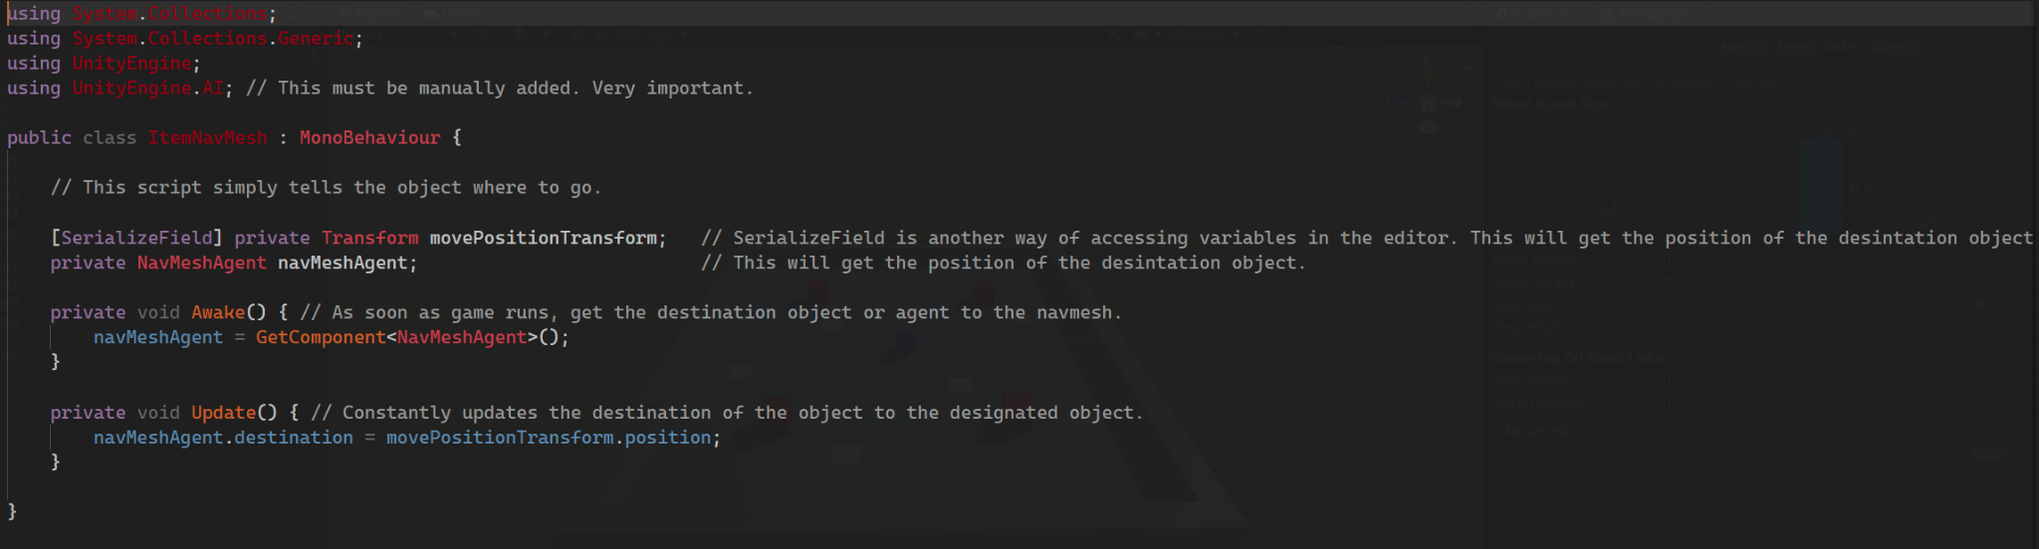
11. Select the Player game object and drag it to the Move Position Transform.
    1. This will ensure that Item1 will be going to the destination of the player based on the transform values of the player.
12. Test the game and watch as the item follows the player.